WISCONSIN CLEAN ENERGY TOOLKIT

PROMOTIONAL MATERIALS

- SAMPLE EMAIL
- SAMPLE LINKEDIN & FACEBOOK POSTS
- SAMPLE TWEETS
- SAMPLE BLURBS TO INCLUDE IN E-NEWSLETTERS OR E-BLASTS
- PRESS RELEASE
- VISUAL ASSETS
- CONTACT

www.wicleanenergytoolkit.com

- SAMPLE EMAIL

Subject Line: ‘Wisconsin Clean Energy Toolkit’ is a guidebook to a cleaner future

Dear [NAME],

Wisconsin Conservation Voters, Sierra Club, and RENEW Wisconsin, released the Wisconsin Clean Energy Toolkit: Developing a Clean Energy Plan for Your Community to empower local communities to address climate change.

Towns, villages, cities, and counties in Wisconsin are building the renewable energy economy and leading the way in confronting climate change. The Wisconsin Clean Energy Toolkit recognizes the leadership in Wisconsin communities and the opportunities to expand these efforts across the state.

As concern over climate change and its impacts deepens, local communities across Wisconsin are eager to develop and implement clean energy plans. Often, they struggle with how to begin from a technical perspective and how to engage their communities.

The Wisconsin Clean Energy Toolkit is a comprehensive guide to energy policy options in Wisconsin. This resource is designed to help guide communities of varying sizes and with differing resources as they consider, craft, and implement clean energy policies, and how to ensure the greatest return on potential clean energy investments.

The Clean Energy Toolkit provides information to help local communities including:
How to understand current state policies and regulations that impact energy use in Wisconsin
- Guidance on how to commit to clean energy
- How to build support in the community for clean energy policies
- How to establish a baseline of current energy use in the community, and how to set benchmarks to track progress toward long-range goals
- Defines equitable carbon reduction strategies that protect vulnerable communities when making the transition to clean energy, and how to ensure all impacted constituencies have a voice at the decision-making table
- Provides an overview of various financing options available to local governments to pursue clean energy

The toolkit is available to download at www.wicleanenergytoolkit.com. For additional information, questions, or to request a paper copy, please contact Jennifer Giegerich (Jennifer@conservationvoters.org).

Thank you,
[ORGANIZATION NAME]

- SAMPLE LINKEDIN & FACEBOOK POSTS

Please find images for LinkedIn and Facebook in 6. VISUAL ASSETS section below.

Post 1:
The Wisconsin Clean Energy Toolkit is designed to help guide communities as they consider, craft, and implement clean energy policies. The toolkit is available to download at www.wicleanenergytoolkit.com.

Post 2:
Towns, villages, cities, and counties in Wisconsin are building the renewable energy economy and leading the way in confronting climate change. The Wisconsin Clean Energy Toolkit recognizes this leadership and highlights opportunities to expand clean energy efforts across the state. www.wicleanenergytoolkit.com

Post 3:
As concern over climate change and its impacts deepens, local communities across Wisconsin are eager to develop and implement clean energy plans. The Wisconsin Clean Energy Toolkit is designed to help guide communities of varying sizes and with differing resources as they consider, craft, and implement clean energy policies. The toolkit is available to download at www.wicleanenergytoolkit.com.

- SAMPLE TWEETS

REMINDER: Use #WICleanEnergyToolkit

Please find images for Twitter in 6. VISUAL ASSETS section below.

Tweet 1:
The #WICleanEnergyToolkit is a comprehensive guide to energy policy options in Wisconsin. www.wicleanenergytoolkit.com #CleanEnergy #Wisconsin #RenewableEnergy

Tweet 2:
. @WIConservation, @SierraClubWI, and @RENEW_Wisconsin, released the #WICleanEnergyToolkit to empower local communities to address climate change. www.wicleanenergytoolkit.com #CleanEnergy #Wisconsin #RenewableEnergy

Tweet 3:
The #WICleanEnergyToolkit recognizes the #CleanEnergy leadership of #Wisconsin communities and offers opportunities to expand these efforts across the state. www.wicleanenergytoolkit.com #RenewableEnergy #Renewables

- SAMPLE BLURBS TO INCLUDE IN E-NEWSLETTERS OR E-BLASTS

Headline 1: ‘Wisconsin Clean Energy Toolkit’ is a guidebook to a cleaner future Headline 2: ‘Wisconsin Clean Energy Toolkit’ helps local communities address climate change

Blurb 1 (35 words):
The Wisconsin Clean Energy Toolkit is designed to help guide communities of varying sizes and with differing resources as they consider, craft, and implement clean energy policies. The toolkit is available to download at www.wicleanenergytoolkit.com

Blurb 2 (59 words):
The Wisconsin Clean Energy Toolkit is a comprehensive guide to energy policy options in Wisconsin. This resource is designed to help guide communities of varying sizes and with differing resources as they consider, craft, and implement clean energy policies, and how to ensure the greatest return on potential clean energy investments. The toolkit is available to download at www.wicleanenergytoolkit.com

Blurb 3: (98 words):
As concern over climate change and its impacts deepens, local communities across Wisconsin are eager to develop and implement clean energy plans. Often, they struggle with how to begin from a technical perspective and how to engage their communities. The Wisconsin Clean Energy Toolkit is a comprehensive guide to energy policy options in Wisconsin. This resource is designed to help guide communities of varying sizes and with differing resources as they consider, craft, and implement clean energy policies, and how to ensure the greatest return on potential clean energy investments. The toolkit is available to download at www.wicleanenergytoolkit.com

- PRESS RELEASE

FOR IMMEDIATE RELEASE: March10, 2020

CONTACT: Jennifer Giegerich, Wisconsin Conservation Voters
608-208-1130, Jennifer@conservationvoters.org

‘Wisconsin Clean Energy Toolkit’ helps local communities address climate change

Madison, WI - Wisconsin Conservation Voters, Sierra Club, and RENEW Wisconsin have released the Wisconsin Clean Energy Toolkit: Developing a Clean Energy Plan for Your Community to empower local communities to address climate change.

Towns, villages, cities, and counties in Wisconsin are building the renewable energy economy and leading the way in confronting climate change. The Wisconsin Clean Energy Toolkit recognizes the leadership in Wisconsin communities and the opportunities to expand these efforts across the state.

As part of its statewide launch, clean energy leaders, including Wisconsin State Treasurer Sarah Godlewski, addressed members of the media and the public across the state on March 10th, 2020 to announce the release.

“The Wisconsin Clean Energy Toolkit will help communities develop clean energy plans, which are good for the environment and also can be good for a community's bottom line,” said State Treasurer Sarah Godlewski. “I've seen this firsthand as the Chair of a $1.2 billion trust fund, how we've helped local governments finance projects such as solar panels that saved taxpayers' money. I hope communities across the state see us as a partner in their projects to address climate change and lower energy costs."

As concern over climate change and its impacts deepens, local communities across Wisconsin are eager to develop and implement clean energy plans. Often, they struggle with how to begin from a technical perspective and how to engage their communities.

“Smaller communities often lack the staff to conduct clean energy assessments and make recommendations,” said Jennifer Giegerich, Government Affairs Director for Wisconsin Conservation Voters. “This toolkit is a comprehensive resource for those considering a commitment to clean energy.”

The Wisconsin Clean Energy Toolkit is a comprehensive guide to energy policy options in Wisconsin. The toolkit is a resource designed to help guide communities of varying sizes and with differing resources as they consider, craft, and implement clean energy policies, and how to ensure the greatest return on potential clean energy investments.

“Local governments, have heard from their residents and they want to shift to clean, renewable energy,” said Heather Allen, Program Director for RENEW Wisconsin. “But they need resources and technical support to make the transition. This toolkit offers practical strategies to help communities access affordable clean energy."

“The Public Service Commission’s Office of Energy Innovation is committed to delivering programs that have a measurable impact on our state, this is why we’ve supported the Energy Independent Communities and will continue to support (with grants and technical assistance like this guide) communities and Tribal Nations on the road to our clean energy future,” Megan Levy, Local Energy Programs Manager & Energy Assurance Coordinator, Office of Energy Innovation, Public Service Commission of Wisconsin.

The Clean Energy Toolkit provides information to help local communities including:
- How to understand current state policies and regulations that impact energy use in Wisconsin
- Guidance on how to commit to clean energy
- How to build support in the community for clean energy policies
- How to establish a baseline of current energy use in the community, and how to set benchmarks to track progress toward long-range goals
- Defines equitable carbon reduction strategies that protect vulnerable communities when making the transition to clean energy, and how to ensure all impacted constituencies have a voice at the decision-making table
- Provides an overview of various financing options available to local governments to pursue clean energy

"As Wisconsinites demand action on climate change, local communities are answering those calls," said Elizabeth Ward, Director for Sierra Club Wisconsin. “We're glad to provide a resource for those communities as they demonstrate the leadership we're missing at the federal level.”

The toolkit is available to download at www.wicleanenergytoolkit.com. For additional information, questions, or to request a paper copy of the toolkit, please contact Jennifer Giegerich, Wisconsin Conservation Voters at 608-208-1130 or Jennifer@conservationvoters.org.

Visit www.wicleanenergytoolkit.com to learn more.

###

- VISUAL ASSETS

FACEBOOK:
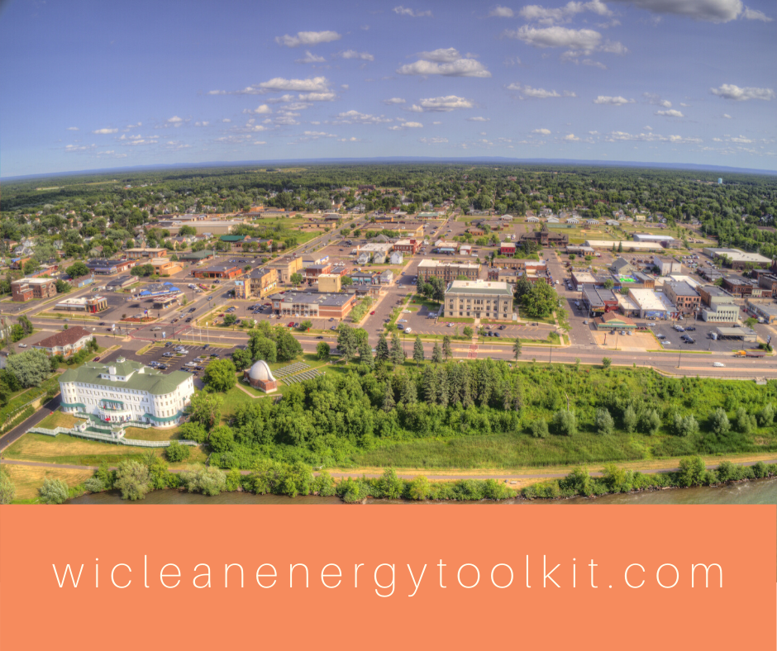

INSTAGRAM:

LINKEDIN:

TWITTER:
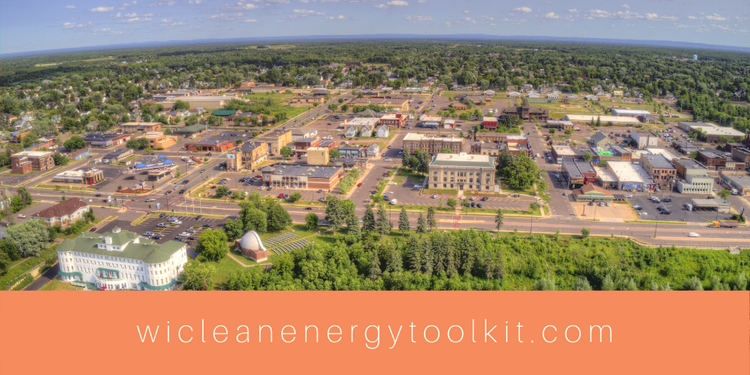

EMAIL HEADER:
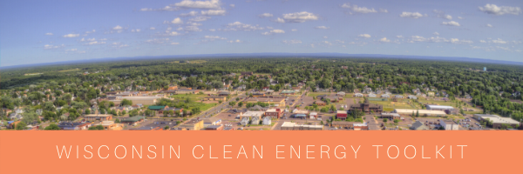

MADISON TOOLKIT LAUNCH:
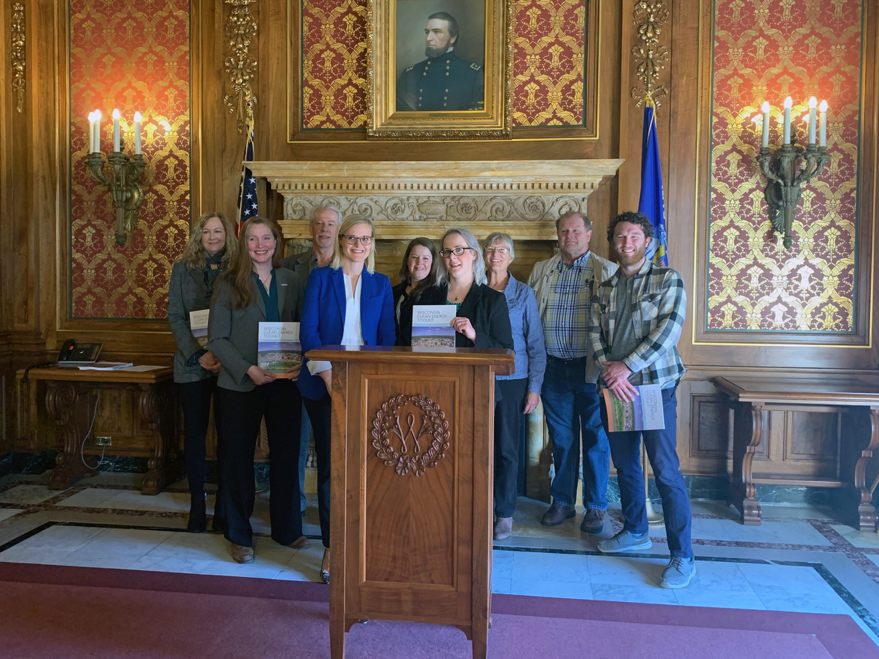

- CONTACT

Need a different banner size or any other promotional collateral? Email jodi@renewwisconsin.org

